LOCAL GOVERNMENT ACT 2003
BUSINESS IMPROVEMENT DISTRICTS (ENGLAND) REGULATIONS 2004

BUSINESS IMPROVEMENT DISTRICT FOR STRATFORWARD

DECLARATION OF RESULT – 28/09/2018

As an agent of the ballot holder for the StratForward Business Improvement District ballot I certify as follows:

Total number of votes cast in the ballot, excluding any given on ballot papers rejected | 172
Aggregate rateable value of each hereditament in respect of which a person voted in the ballot | £9,996,500
Total number of votes cast in favour of the proposed Business Improvement District for StratForward | 121
Aggregate rateable value of each hereditament in respect of which a person voting in the ballot has voted in favour of the proposed Business Improvement District for StratForward | £8,720,700

I hereby declare that the proposal to establish a Business Improvement District for StratForward is approved. A majority of the Business ratepayers in the proposed BID area who voted, voted in favour of the proposal, both by aggregate rateable value and numbers voting.

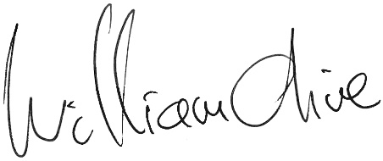
William Olive
Deputy Manager

Notes:
The total number of ballot papers rejected was as follows:
4 Unsigned, unmarked or void for uncertainty

Total: 4

