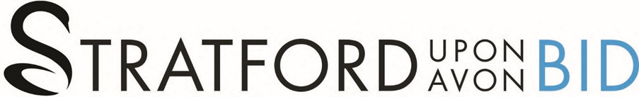



STRATFORD UPON AVON BID
ANNUAL REPORT 2022
FINANCIAL YEAR END MARCH 2022

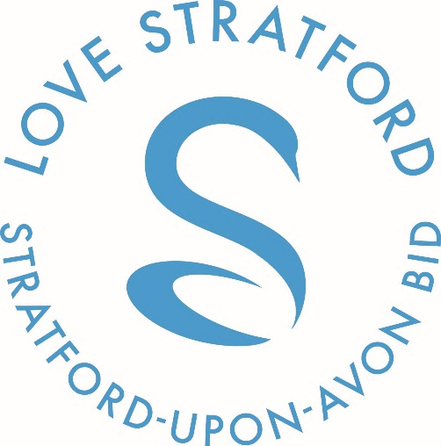

Dear Levy Payers
I write to you with an update on Stratforward BID Limited’s progress in delivering Stratforward’s BID3 Business Plan over the last 12 months and plans we have going into the next financial year. The last 12 months have seen the BID go through many changes and challenges. As you all know, the BID Board appointed Diane Mansell, our new BID Manager last year and she started with us in January 2022.
Diane has been working behind the scenes with the team and the Board to reduce the operational costs, improve the services we currently deliver and make positive improvements to our governance structures. It’s important to us that you understand how we spend the levy and that you are receiving the most from your investment into the BID.
After a lot of work we feel we are now in a position to relaunch the new brand Stratford Upon Avon BID and give you a more detailed update on all of the projects that are going to be delivered over the next 12 months. I also want you to know that in a year where we couldn’t invest in large scale public events the Board have redirected those resources into improvement projects that will help deliver a cleaner, greener, safer town centre for the benefit of all our businesses, residents and visitors over the next 12 months.
Exciting times are ahead of us and the dawn of a new era for the BID
Kind Regards
Josefine Blomqvist
Chair Stratford Upon Avon BID

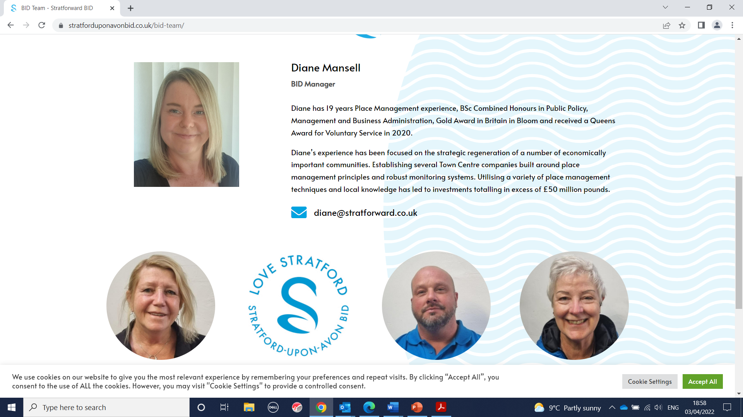
Thank you for making me feel so welcome over the last 12 weeks. I am loving getting to know you all and look forward to working with you in the future.

I would like to start with explaining what’s been happening in the development of the BID’s Operational Governance since I have taken over. Then the rest of the Annual Plan showcases the updates happening in each of the BIDs 4 key objectives.

Hope you find the projects as exciting as us.
Kind Regards
Diane Mansell
BID Manager Stratford Upon Avon BID

Operational
Improved Governance Structures are now in place, allowing for the delivery of better BID services. Improving our company governance structures and transparency, will allow us to apply for British BIDs and the BID Foundation accreditation schemes. This will showcase that our governance structures are benchmarked against the highest BID industry standards in the UK and give our Levy Payers faith in our management systems.
- British BIDs Accreditation is the industry recognised standard, externally assessed by independent auditors, and designed in line with the National BID Criteria and the National Guiding Principles for a BID.
- The BID Foundation accreditation is to increase the transparency, accountability and professionalism of the BID industry. Developing a set of simple standards was one of 13 recommendations suggested by the Institute of Place Management (IPM) in a state-of-the-art review of the industry. The IPM advised all BIDs to publish important information about their management and governance on their website, for Levy Payers and wider stakeholders to have confidence in their operations. The Industry Standards have been developed through consultation with members of The BID Foundation Council, the British Retail Consortium, Ministry for Housing, Communities and Local Government.
As part of this improvement the BID Organisational Structure is changing giving the BID the skills and person power to deliver everything we have promised in the BID Business Plan. Please see below:
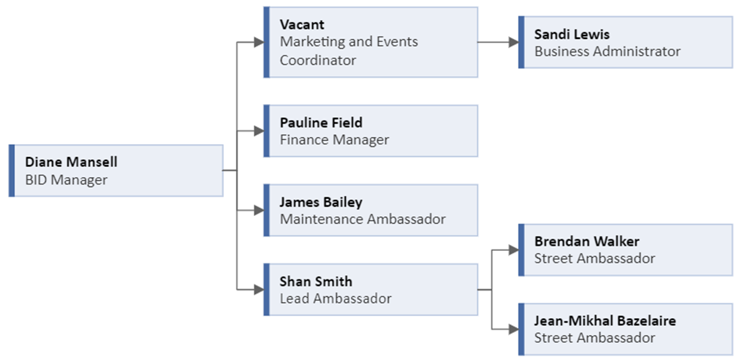
We have also made it easier for you to make contact with the team
- Changing the BIDs working shift pattern - This will allow us to have improved security patrols on at all times, while also providing access to either the BID Manager, Marketing and Events coordinator or Lead Ambassador on a weekend making sure there is always a member of the management team working at all times.
- Office Open days - Starting in May 2022 we will be launching office open days, every other Monday giving all of our Levy Paying Businesses the option to pop in to see the BID Manager and Marketing and Events Coordinator and have a catch up and a cuppa without the need to make an appointment.
- All BID staff members will hold photographic ID cards so you know you are speaking with a genuine BID staff member.
- Office Land Line Number – 01789 299 011
- New Email Addresses and mobile contact details. A photographic document will be delivered directly to all BID Levy payers showcasing what the team look like and how to directly contact them.

Representing Stratford
Working with our Levy Payers, Local Authorities, grant funding bodies and other key Stakeholders, we believe that together we can continue to develop Stratford upon Avon’s unique and historic town centre, giving people more reasons to visit and stay.

Giving all of our Levy Payers the ability to get involved in consultation events as and when they arrive by holding consultation days in our offices on Sheep Street.

Diane Mansell our BID Manager represents our BID and the needs of the Midlands region on the British BIDs Advisory Board and Accreditation Panel.

Savings
- April 2022 see’s the relaunch of the Employee Discount Scheme with a new card design, window sticker for participating businesses and new offers. The discount scheme supports employees of our BID businesses by offering discounts within local businesses.
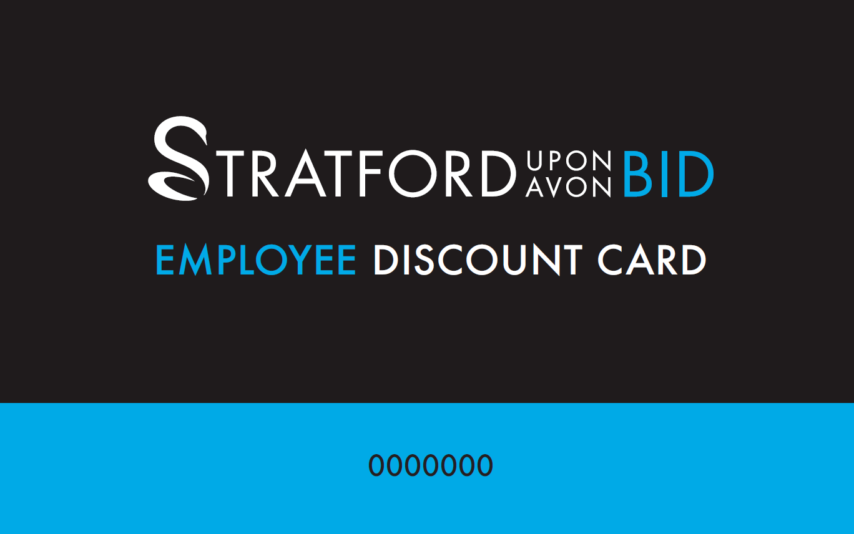

- Launching the all NEW SMARTA business services costs reduction program in April 2022 to give businesses free access to cost reductions on utility bills. More details of the FREE scheme is on the new site https://stratforduponavonbid.co.uk/smarta-benefits 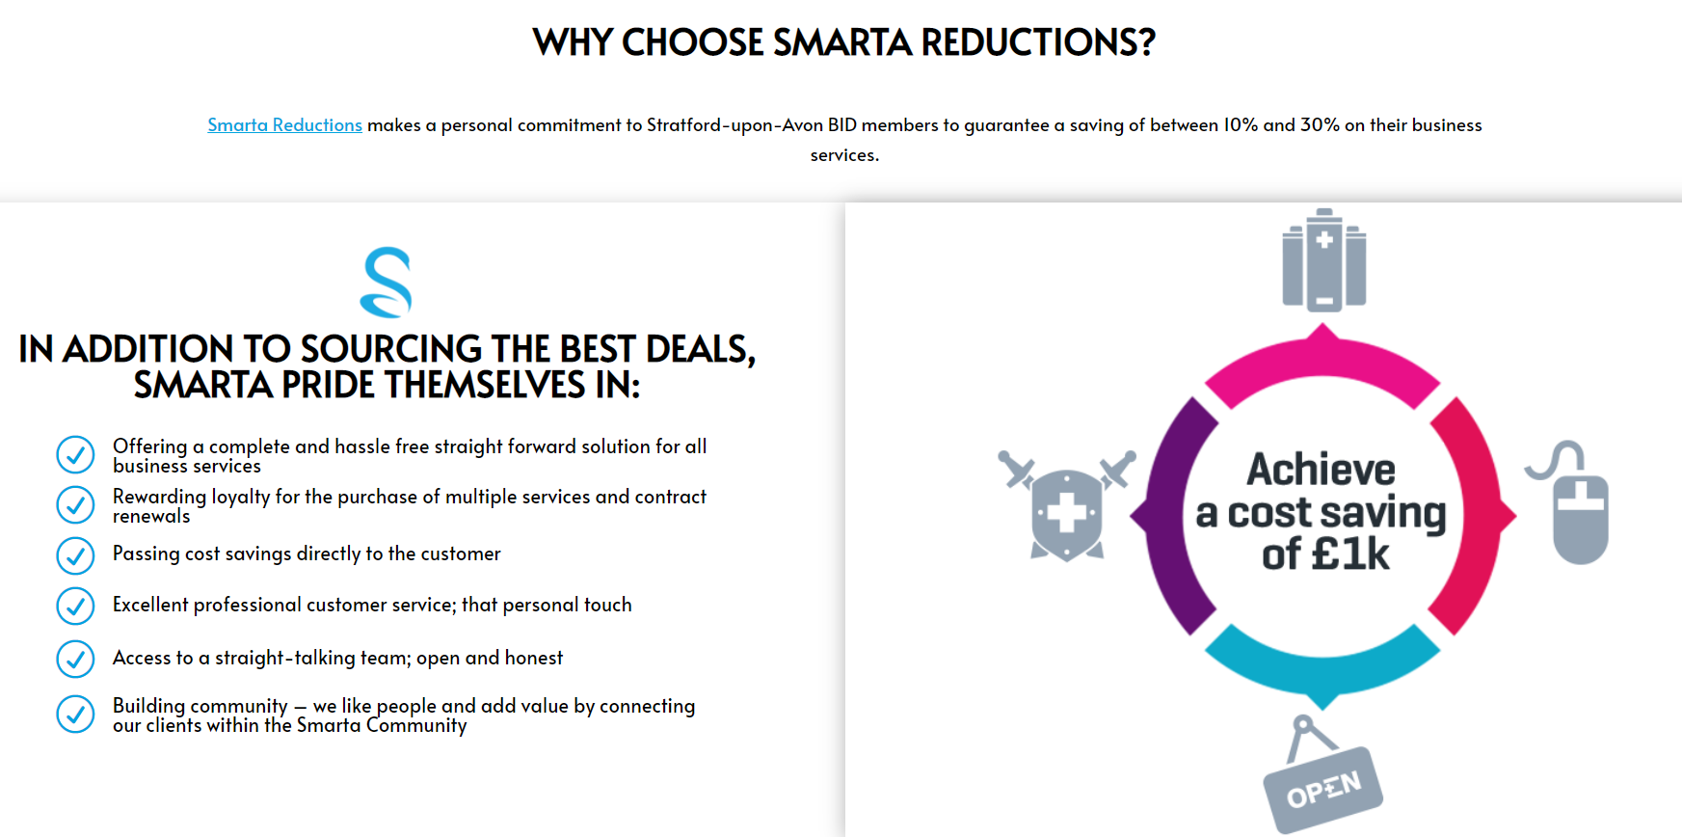

- Office refurbishment has given us the ability to offer FREE of charge a 10 - 14 person meeting/ training/ interview space for our Levy Payers and local community groups to use. To book the office space please call and speak to Sandi Lewis, Business Administrator.

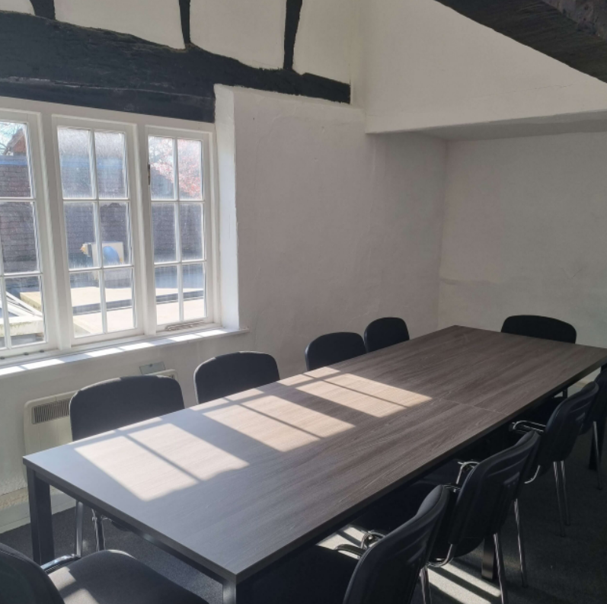
Hosting and Welcome
- This April we have launched the all NEW 7 day a week Ambassador Service. The brand new, fully uniformed service will improve visitor experience, business communication, direct support and increased incident reporting. The service will be delivered in the following ways:
  - The Street Ambassadors role will provide 3 full time Ambassadors to provide a high-profile on-street visitor experience service to users of the Stratford Upon Avon BID Area. Street Ambassadors support the organisation via the delivery of:
          - Daily security and safety patrols of the area reporting and responding to any issues found
          - Building relationships with businesses and offering better communication and business support
          - Managing distribution of BID information and marketing materials to BID Members

  - The BID Maintenance Ambassador role is to provide a high-profile on-street maintenance service to users of the Stratford-Upon-Avon BID Area. Creating an environment that offers a warm welcome to visitors and the general public. The Ambassadors role is the “eyes and ears” of the Business Improvement District, sharing relevant information with BID businesses and monitoring and reporting on issues that affect the environment of the BID area. The role supports the organisation via the delivery of:
          - Daily highway inspections and reporting issues.
          - Regular street furniture maintenance.
          - Daily fly posting, sticker and graffiti removal.
          - Ad hoc cleansing.
    - NEW FREE PAT Testing service for businesses to access between September and March each year. More information and how to book the service will be given later in the year.
    - Low level painting projects to improve business frontages and the town centre environment.

  - Volunteer Ambassador program will provide a positive, friendly, welcoming and visible presence in the BID area. The aim of this support is to improve the visitor experience, to ensure the town is welcoming to our businesses and visitors during peak periods including events, weekends and school holidays. If you would like to get involved there is more information including a volunteer Ambassador program job description on the website.
  - Bardwatch - The Bardwatch system helps to maintain very low levels of crime & disorder in Stratford-upon-Avon and allows us to extend a very safe, relaxing welcome to our visitors. The system is now jointly administered by Stratford-Upon-Avon’s Ambassadors in conjunction with Warwickshire Retail Crime Initiative. The system provides hand-held radio communication between daytime and evening economy businesses, as well as intelligence and exclusion schemes via the Warwickshire Retail Crime Initiative. The Warwickshire Retail Crime Initiative Limited is a countywide Partnership approach, to prevent and reduce crime and anti-social behavior in retail and licensed business premises in Warwickshire and it is provided free of charge to BID levy payers. Stratford Upon Avon BID encourages as many businesses to become part of Bardwatch as possible, with radios available to buy or rent at very reasonable rates for everyone who joins.
  - Police Team – Developing better connections with the local policing team to reduce ASB, begging and shop lifting.

Promoting Stratford
- As promised in the BID3 Business Plan, the company has undertaken a complete rebrand. We are now trading as Stratford Upon Avon BID. This gives us the ability to market the town more proactively. Alongside the new brand, ALL staff going forward will be wearing uniforms. This is to dramatically increase visibility of the BID team.
- Developed Social Media - Improved focus on Social Media channels under the Stratford Upon Avon BID brand name making it easier for visitors to find out information about the town centre, our events, activities and your Businesses. Below shows the current followers on our social media channels:
  - Facebook - 2848
  - Instagram - 5952
  - LinkedIn (Launched in the last 3 weeks) - 50
  - Twitter - 4390
- To compliment the rebrand we have launched an all NEW Stratford Upon Avon BID website. The new website which, launched on the 4th April 2022 has been designed to meet the BID Foundation accreditation guidelines. The site, will give all of our Levy Payers the ability to access all our company information, member benefits and see how to contact their sector representative on the Board for support. The site will also deliver an upgraded business directory, job vacancies, experience Stratford information for visitors and other new and improved opportunities for our Levy Payers.
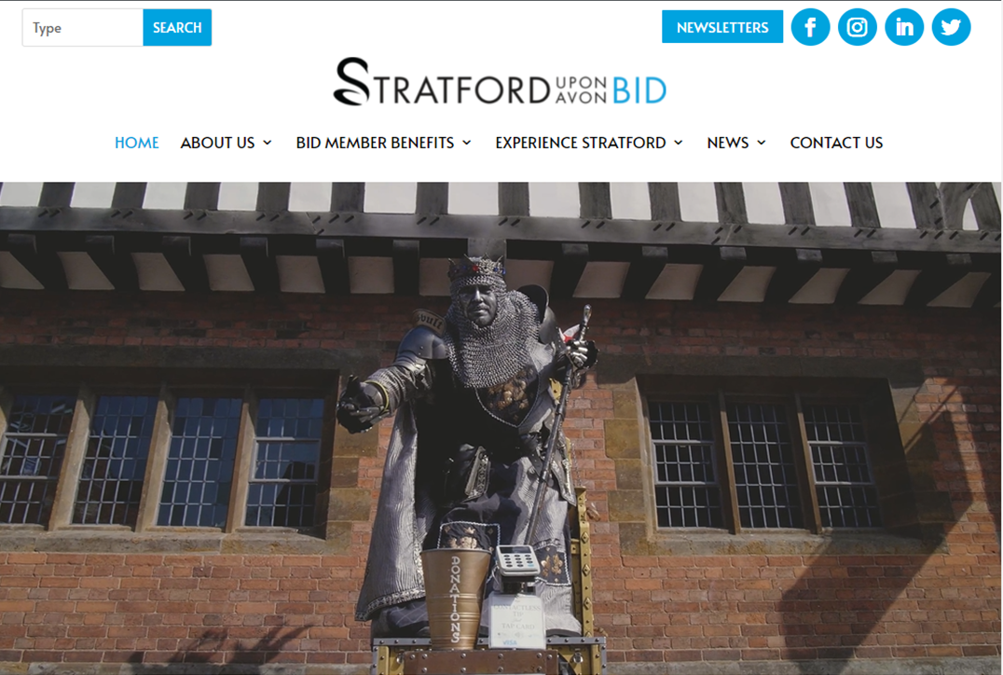

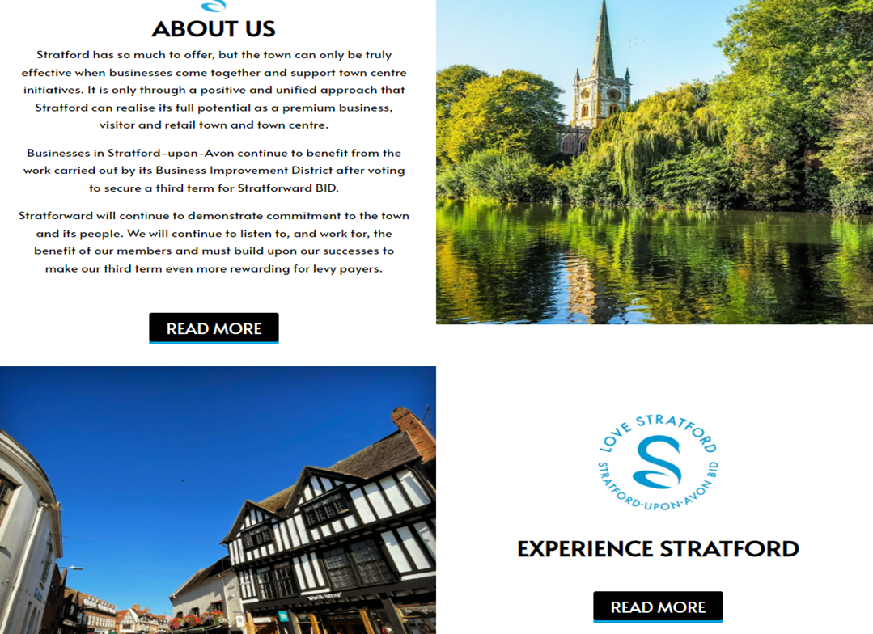

- Wi-fi and Footfall counters
  - The town Wi-Fi and Footfall counters are currently being upgraded. 3 Wi-Fi terminals are being refitted into the town with an extra 3 footfall counters fitted in areas that have previously not been covered including Henley Street and the top of Rother Street improving the accuracy of the data we receive from the equipment.
- Marketing and Events
  - A newly appointed Events and Marketing Coordinator will be starting with the company shortly to drive quality marketing, events and increased footfall in the following ways:
    - Networking opportunities
      - Launch of Quarterly themed networking events
        - More information to come on this but if you are interested in hosting a themed networking session please contact the office to log your interest.
      - Extended events program over the next 12 months to encourage a wide range of visitors to the town
        - Introduction of 2 days of Easter activities working with Escape Arts
        - 3 day Motor Festival on May Bank Holiday weekend

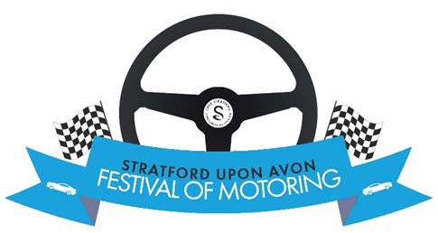

        - 4 day Jubilee Festival on June Bank Holiday weekend – sponsorship opportunities available
        - Summer entertainment program is currently in development
        - 3 day Food Festival in September – sponsorship opportunities available

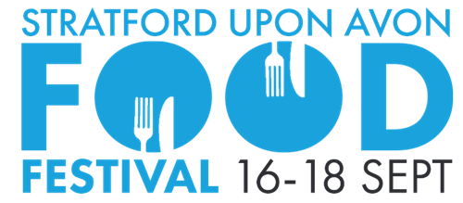

        - All NEW Halloween Pumpkin Patch event during October half term
        - Christmas Lights Switch On moved to a Saturday to improve ease of access to the event for local families and increase footfall for town centre businesses.
      - New lighting trail equipment has been purchased, giving us the ability to deliver better town trail activities. More information will be sent out shortly about this.
    - Improved marketing activities
      - Production of quarterly seasonal brochures to promote the town, our activities and events. Advertising opportunities available.
      - Development of Tour Company guide days to encourage more group booking activities and overnight stays.
      - Continued delivery of the Ambassador Tours for employees of BID Levy Payers, to give them more knowledge and information about Stratford Upon Avon’s attractions and more information about the town in general.

