Warwickshire County Council Position Statement regarding the Control of Advertisements for Charitable or Public Events within the Highway Environment at Stratford upon Avon.

It is illegal to display any advertisement on the public highway, including on highway furniture such as signs, railings and lamp posts, without the permission of Warwickshire County Council who are the Highway Authority.
The County Council recognises that it is traditional for public and charitable events to be promoted in and around the town centres of Warwickshire by fixing posters and banners to highway furniture. The Council is committed to supporting local charity and community events and therefore will not remove this type of advertisement from the areas identified at Appendix A or take further enforcement action providing that all of the following conditions below are met:
- The advertisement is for a local event being held for charitable purposes.
- The advertisement is kept clean and tidy
- The advertisement is kept in a safe condition
- The advertisement does not obscure or hinder the interpretation of official road signage
- The advertisement does not inhibit visibility for drivers or pedestrians
- The advertisement is not fixed to posts that that have an electrical supply.
- A maximum of 5 vinyl banners and/or 20 posters per organisation are to be displayed within the town any one time
- The event organiser has public liability insurance of a minimum of 5 million pounds to cover third party claims arising from the situation of the advertisement
- Warwickshire County Council is informed of the event organiser’s intention to display the advertisement by email to chsouth@warwickshire.gov.uk at least 14 days before display. Alternatively via 01926 412515
- The event organiser or person responsible for the advertisement has obtained express consent from Stratford District Council(SDC) as Local Planning Authority where this is required (see below*). SDC can be contacted on 01789 260616
- The advertisement is displayed no more than 14 days before the event and is removed no more than 7 days afterwards.
- The advertisement is removed if required by the County Council, the District Council or the Emergency Services.

Event organisers should note that it may be necessary for the County Council to remove the advertisement immediately if it is deemed to be a danger. In this case the advertisement will be returned to its owner or where the owner is not known it will be retained by the County Council for a period of 1 month after which time it will be disposed of.

*In addition to permission from the landowner or the Highway Authority some advertisements require express consent from the Local Planning Authority (Stratford District Council). Temporary advertisements for public, non-commercial events that are no larger than 0.6m², are not illuminated and are displayed no earlier than 28 days before the event or activity and no later than 14 days after the end of the event or activity will not usually require express consent. It is the responsibility of the event organiser to check with the local planning authority whether express consent is required and to obtain this if necessary.

Appendix A

Advertisements at the following locations that comply with the above conditions will not be removed or subject to enforcement action by the County Council

- Banbury Road/Shipston Road roundabout

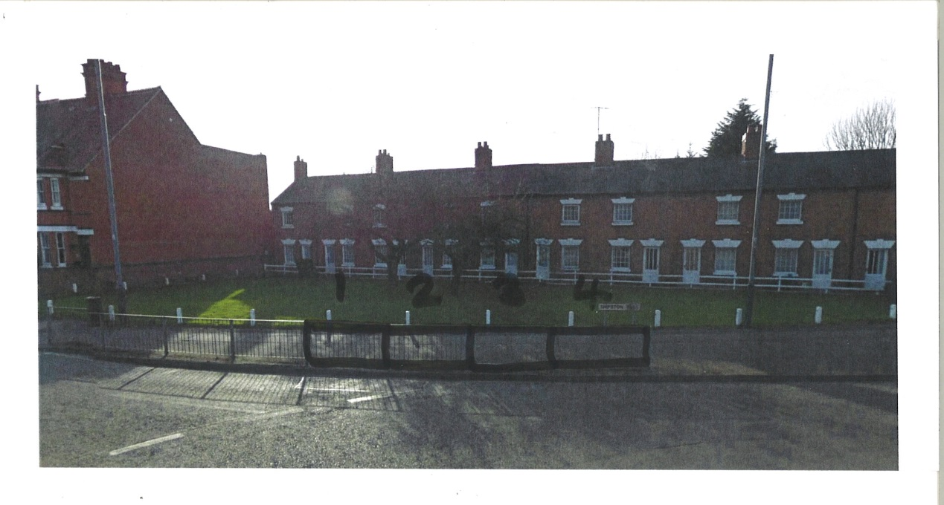
- Outside the Mulberry Centre

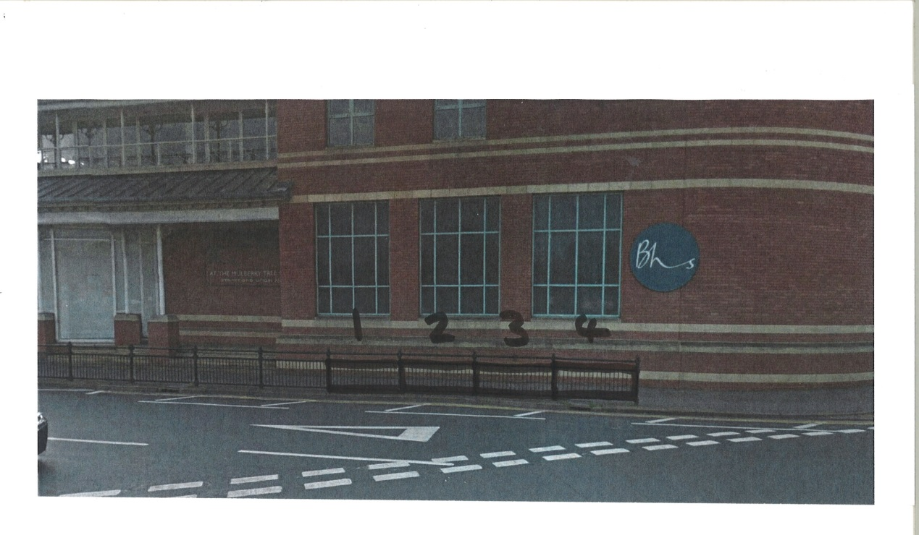

- Seven Meadows Road/Evesham Road roundabout

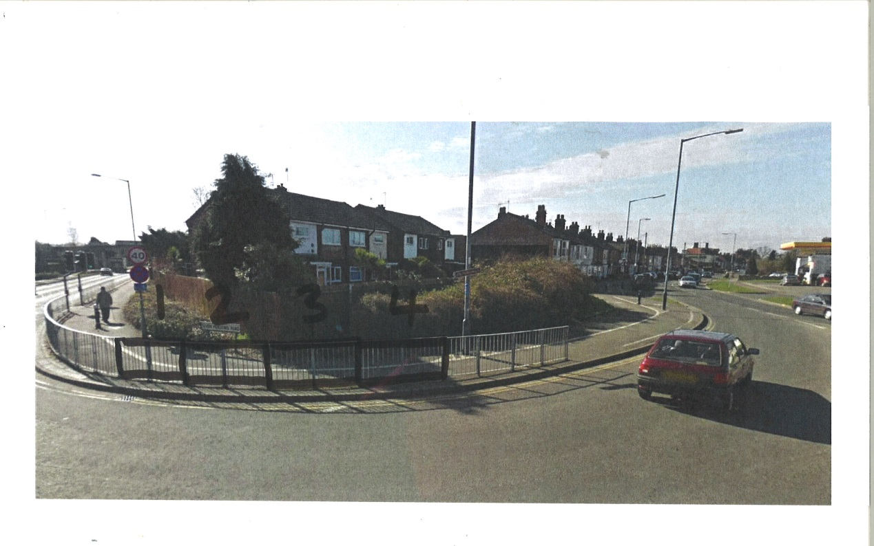

- Rother Street/Wood Street junction

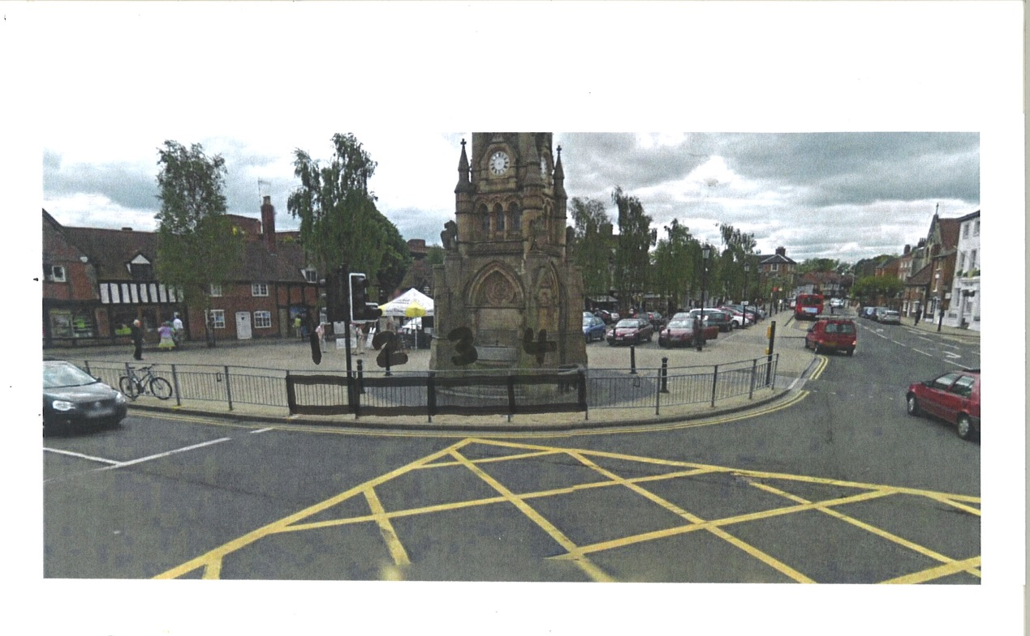

Please do not put signage at the following locations due to safety concerns:
- A3400 Birmingham Road/Maybird roundabouts
- A422 Alcester Road/Morrisons roundabout
- Sanctus Road overbridge
- A3400 Gyratory pedestrian crossing triangle – outside the Tourist Information Office

